2020 BOOTH IMPACT AWARDS
NOMINATION PROCESS GUIDELINES AND RULES

The Booth Values:

The Booth Impact Awards are designed to recognize outstanding contributions by staff members who exemplify the Booth Values.

Staff Values Statement:

Chicago Booth has an extraordinary impact on business research and education worldwide. As Booth staff, we play an indispensable role in making this impact by creating a work environment of trust and empowerment through respect for each other, excellence in our work and integrity in our actions.

A closer look:

- Respect:
  - Defined as: fairness, valuing each other for uniqueness, embracing diversity
  - Demonstrated through such things as: originality; self-expression; sharing and listening to different points of view; cooperating with others as you work towards a common goal; giving others the “benefit of the doubt”; and helping others to do their best.

- Excellence:
  - Defined as: being exceptionally good, setting new standards, pushing boundaries
  - Demonstrated through such things as: succeeding in reaching individual and team goals; giving 100%; demonstrating responsibility and accountability; being conscientious.

- Integrity:
  - Defined as: honor, strength of character, transparency
  - Demonstrated through such things as: honesty; fairness; straightforwardness of conduct; trustworthiness; direct and truthful

All of the elements of the Staff Values lend themselves to making an “impact”. And it is through this impact that we hope that the contribution of the Staff makes a lasting difference and leaves an indelible legacy.
BOOTH IMPACT AWARDS

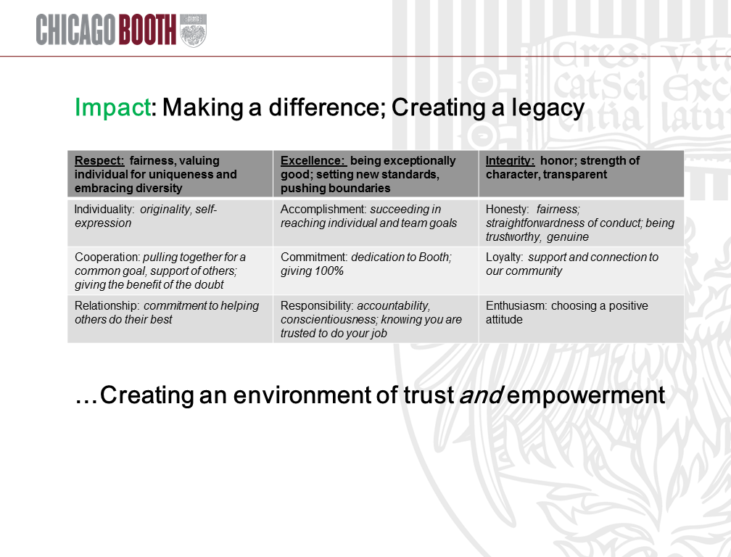

THE RULES

Rules for Nominating - All nominations must fit these parameters:

- Staff Awards nominations are open to all full-time and part-time staff who are employed at the
University of Chicago Booth School of Business.
- Business Management Group, temporary employees and contractors are not eligible to be nominated.
- Any staff member may nominate a colleague, direct report or those who manage people; staff are encouraged to think about colleagues outside of their own team when proposing nominees.
- Self- nominations will not be accepted.
- An individual may not receive the award two (2) consecutive years in a row, but may be nominated each year.
- Nominees must have at least one (1) complete year of service; (If, however, a nominee is a
member of a team and s/he has less than 1 year of service, the team will still be eligible.)
- Nominees must be in good standing (i.e. not on a PIP, no performance or disciplinary concerns).
- We encourage staff to nominate not only individuals, but teams as well. Teams may include members of a department or project teams. The team is defined by the nominator. Nominator must be able to explain why they consider this a team versus a work group or colleagues who work together sharing the same interest, but not necessarily the same department/project goal.
- The nomination period will open April 13, 2020 and end on June 12, 2020. Nominations received after 11:59pm on June 12, 2020 will not be accepted as they will be considered late.
GUIDELINES

Guidelines to assist with your nomination(s)

As you prepare your narrative in support of the staff member or team that you will nominate, we hope you will find the following guidelines (i.e. examples) useful. Your narrative must highlight examples of respect, integrity or excellence that have had a positive “Impact” on Chicago Booth.

INDIVIDUAL STAFF EXAMPLES:

Example (A)- From a real nomination (name has been changed)

I believe that Sharon truly deserves a Booth Impact Award. I've had the privilege of working with her for a few years and have seen her exemplify the Booth values on a number of occasions. Let me explain.

IMPACT: Our department is an outward facing department and Sharon is instrumental in articulating our message to alumni. She helps the team with their Annual Fund solicitations which helps the school raise about $6M a year. She also supports all of the major events including pre-event marketing, day-of coverage responsibilities and post-event wrap ups. She helps our department speak with one voice to
our 48,000 alumni. The impact she has had has been on the fundraising support and the events and communications from the Alumni Relations team.

Sharon is also a very strategic thinker who is able to see the bigger picture and tie the various events
and solicitations together so they provide the same message to our alumni. All of her work highlights the school's excellence, the power of our alumni and the great potential of our students.

RESPECT: I've seen Sharon navigate some pretty tough situations at Booth. Often times her department has one way of doing things and our department has another way of doing things. None of this is bad but it's just that sometimes we take different approaches. She always keeps her cool and is so good in these situations. I've actually just sat back sometimes and watched her deal with tough situations and she is so graceful and respectful. She really listens to what the other party is saying and does her best to relay her point. The respect that she has for people and their work creates impact because the final product is always a win-win. She is able to artfully negotiate the situation in a way that is good for both sides.

INTEGRITY: I was working on a project for the student orientation and I wanted to do a video to introduce the day to students. This video was important in helping to frame the day for students and get them excited about the alumni community. Sharon and I put a timeline together and agreed to work on the project at a later date when things weren't so busy. This was all happening during the RECONNECT time so everyone was extremely busy. Well, we found out that David Booth would be in town LATER THAT WEEK and would be open to helping us with our video. It was a very tight turnaround and Sharon could have said no. She could have said that there was not enough time to do this given the constraints she and her team had. But she said YES. She was excited and truly believed that his contribution would
help our video and therefore, the event. She went above and beyond the call of duty because she truly believed that this was the right thing to do and the right thing for our event and our students.

From my experience thus far at Booth I think that working in the role that Sharon has would be tough. You have the "client" that wants what they want when they want it and you have the department in which Sharon works trying to manage expectations and streamline strategy. She has such grace and so much commitment to Booth. It's a tough job but she it does so well. Like I said before I sometimes just watch how she interacts with people and navigates tricky situations ... there is a lot to learn from her! She is an extremely effective staff member and a huge asset to the Booth community. I truly believe that she 100% deserves to be recognized for the impact she has had on Booth

Example (B)

Dion is a great example of someone who has made a positive impact on Chicago Booth by executing their work with integrity. Dion is on the Corporate Development team in Career Services and travels a lot to South America. When Dion is traveling he meets a lot of alumni who are graduates of the University of Chicago’s undergraduate college and has done a great job at building relationships with them, too. When Dion is doing his work he upholds the integrity for the university as a whole because he is not just thinking about Booth but rather he is thinking about how he can truly have an impact on
the whole institution. Of course, Dion gets his job done for Booth (and with excellence, I might add!) but his good character, wholehearted commitment to the University of Chicago and broad understanding of the needs of our alumni make him someone who creates impact that goes beyond his job description.

Dion works closely with Chicago Booth alumni in Chile and he has found them to be very passionate about the school and university. The alumni there want to do all they can in order to help the institution as a whole. Of course they are passionate about Booth but to them, the institution is one entity with no barriers between schools. So they not only want to help Booth with recruiting but they also want to help the College with admissions and place undergraduates in high-profile internships. Dion understands that if he is to build meaningful and mutually beneficial partnerships with the alumni in Chile then he will have to think outside the box. As such, Dion spent the month of August 2013 reaching out to and meeting with his counterparts in different divisions and departments (the college, Booth admissions, Booth and Central’s alumni offices, the Harris School and the Law School) to better understand their needs. In October 2013 Dion and three other staff members from the university traveled to Chile together to meet with the core group of alumni and discuss ways to meet their needs. Dion does not view his role as being just for Booth or just for Booth alumni. He sees the bigger picture and is really authentic in his approach. As a result Booth not only made substantial headway with corporate
recruiting but they also developed new relationships for other parts of the university. It would have
been easier for Dion to do work for Booth only but he took the high road and approached his work more broadly.
Another example of Dion’s integrity can be seen through how he builds trust across departments and gains the respects of those around him. When Dion took the job there was a lot of work to be done to not only build corporate ties but also rebuild some corporate ties. For reasons beyond Dion’s control some of the corporate relationships that Booth had were not in good standing and Dion approached these situations with an open mind and commitment to resolve them. There is one example that comes to mind immediately. Dion visited the recruiting team at this company and his only agenda item was to hear them out. After the meeting he set up quarterly meetings with one of the main contacts there and slowly began to rebuild the relationship. Dion quickly built trust with this key contact and exhibited the responsible and professional behavior that was needed to fix the situation. After a few months this company has begun recruiting again at Booth! Dion has proved to those around him that an honest, open minded, committed and responsible approach (i.e.: the highroad!) will always win.

TEAM EXAMPLES:

Example (A)

The Student Group Advisor team embodies the main values of Chicago Booth: impact, integrity, empowerment, respect and trust. The Student Group Advisors mission is to provide student group leaders with guidance and support in planning student group activities and conferences. This role can quickly become complicated and nuanced as SGA must balance the expectations of the ambitious and eager incoming class with the guidelines and policies of Chicago Booth. The Chicago Booth SGA team quickly earns the trust of the students early on in their fall semester through clear and direct communication, and empowers them to make decisions on their own as future business
leaders. Additionally, the team makes the balancing act look easy by remaining encouraging and supportive of the student’s desires while setting appropriate boundaries to compile with the school’s guidelines and maintain the integrity of Chicago Booth run events. Additionally, the SGA is collaborative in its approach, ensuring all necessary internal departments, from Corporate Relations to Alumni Affairs to the Dean’s Office, are kept abreast of upcoming conferences and events.

The Student Group Advisor team is also able to act with grace and calm under stressful situations. Last year a speaker cancelled less than 24 hours before a major event and they were able to think quickly and tap into personal contacts in order to find an appropriate replacement just hours before the kickoff of the event. Finally, if anyone has ever walked into the office, they will find themselves greeted with a
warm smile and an eager helper, whether they are an old friend or a new acquaintance of the university.
CROSS FUNCTIONAL TEAM EXAMPLES:

Example (A)

A department head was given an assignment that had a tight deadline and affected 8 other departments. She appointed someone from her staff to contact people from each of the departments
to form a group of people who would discuss how to implement the assignment. A group of people who
had never worked together before got together and decided on specific tasks, assignments and deadlines. During the process one team member was promoted to a new position but volunteered to stay a member of the task team to help everyone complete assignments. Another team member resigned from Booth and everyone else split up her responsibilities. Another team member was spending a lot of time on the project and the person’s boss was getting upset. The entire team wrote a letter to the boss to say how valuable this person’s work was. The boss had no idea all of the contributions this person was making. Team members were able to use their own skills – even when those skills weren’t part of their Booth job – to get the work done. For example, one of the people used to be a court reporter and was able to produce detailed accounts of all of the meetings. The team was running up against some tight deadlines and someone had an idea for shortcuts that might have been viewed as inappropriate. Collectively they found an appropriate alternate solution. As the deadline approached, several late evening meetings were required to complete the work. The project was completed ahead of schedule and exceeded the expectations of the department head.

Example (B)

The Project Management (PM) team within the IT department was tasked with building new software for the school which would affect many different users – from staff in the program offices, the registrar and the alumni office. The PM team assembled a 10 member cross-functional team, called the Solutions Team, to help identify the requirements and timeline for the project. From the outset the Solutions Team approached this high-profile, and important project, with respect for all of the users involved. My department represents one of the main users and from the very beginning I was included in the discussions to help build this new software which was exciting on one level, but nerve-wracking on another because it was so important to create the right solution.

I was invited to join an important meeting where we were responsible for prioritizing the requirements for this project. All of the stakeholders in the meeting wanted their requirements to be heard and made a priority but the project. The Solutions Team did a fantastic job at running the meeting in such a way where everyone got a fair chance to speak and state the case for their requirements. This created an environment of respect for everyone in the room and they allowed all of the stakeholders to be heard. After all of the cases were made we conducted a voting process to prioritize the requirements.
I was so impressed with the way the meeting was run that I asked one of my staff members about the Solutions Team. I asked, “What is it like working on this project?” She told me how it is a lot of work but very rewarding and engaging because everyone’s opinion is sincerely heard and taken into consideration. The Solutions Team has created a culture of respect for the individuals involved and thus
created a committed working group that is motivated to identify the best solution for this new software. It was great for me to hear that this culture of respect on this team was not just demonstrated in the important meetings, but it is the foundation of this team. My staff member went on to tell me how
much she has learned by being on this project: about other departments, IT, and about how technology can truly be used to help advance the school.

The Solutions Team is not just a working group to get something done. They are more than that. They are developing employees, learning about the requirements of the stakeholders and trying to develop a solution that meets the most needs as possible.

I nominate the Solutions Team for an Impact Award because of the respect that they not only have demonstrated for all the key stakeholders, but also for the respect they have for their team members.

From the Evaluators point of view:

We also thought it would be helpful to include insights from the Evaluators who read the nominations
from past Impact Awards. Hopefully this will help you glean further understanding about not only how the nominations were written, but how they were viewed in the selection process.

“We read over ninety nominations. To stand out, it is really important that we see how the individual
or the team excelled in what they did and how they demonstrated the Booth Values in the process.”

“One of our instructions – in order to be completely objective – was to rate each nomination as though we do not know the nominee. We can use ONLY what is submitted to determine if a nomination is worthy of an Impact Award. This takes a lot of time and work on the part of the nominator but is really the only way to help the evaluators understand the impact of the nominee”

“I was a ‘judge’ under the prior staff awards as well as an evaluator for the Impact Awards. The impact awards are so much more objective, but really rely on what the nominator writes. I think the nominators that include commentary from other people is really helpful as well.”

“Making sure the person’s contributions are really “above and beyond” the normal high expectations of day to day performance is a very important piece of information in the nomination. The nomination criteria provided good examples, but a lot of the nominations didn’t follow the process. It’s hard to “read between the lines” and we didn’t want to rule anyone out because we lacked information. Being an evaluator really helped me understand the importance of how succinct and descriptive the nomination needs to be written.”

